0
Question:
Recently i switched to Ubuntu/Linux and searched for some good text editor and i found Sublime Text, i'm very beginner at coding and i was using Notepad++ in windows.
After i downloaded sublime text, i tried to write some codes in javascript to see if it works but it said "No Build System" and when i looked for it, i didn't find any guide for linux... in Notepad++ all i have to do was click run and ta da, the output screen was there.
I don't know much about linux or sublime text, my exact question is how can i run and see my codes in the output screen, currently i'm working on Javascript and i have no idea what a "Build System" is, i just want to type some basic code in sublime text and see the result on the screen, so if you help me i'll be much appreciated.

Answer:
In order to explain your problem it's first important to realize that although the feature is called build, it applies just as much to running an interpreted program as it does to actually buildinganything; think of it less as a "build" tool and more as a "run some external program to do something" tool instead.
With that said, Sublime comes pre-installed with a few different build systems for various languages, but JavaScript isn't one of them. Possibly this is because it's generally unclear whether a particular JavaScript file is meant to be used in a browser, or executed via something like node, but that's just a guess.
In your case, the text No build system is literally telling you that you have told Sublime to automatically select an appropriate build system for the type of file that you're editing, but that it didn't find one and so there's nothing that it can do.
The solution to the problem would be to either install a third party package that includes a JavaScript build system (see Package Control) or create one yourself.
A good rule of thumb for Sublime is that if there is a command you can execute from a command prompt that will do what you want, and you don't need to interact with that command (i.e. it doesn't need to ask you questions before or while it does something), you can set up Sublime to run that command for you.
One tool you can use to execute JavaScript is NodeJS, which provides a command named nodethat can execute JavaScript files if you install it:
tmartin:dart:~> cat sample.js
console.log("Hello, world!")
tmartin:dart:~> node sample.js
Hello, world!
Since this is a command that we can execute from a terminal to do what we want, and it doesn't require us to interact with it to tell it how to do anything, we can set up a build system to use it.
As an example of how to do that, select Tools > Build System > New Build System... from the menu, and then replace the contents of the file with the following code, then save it in the location that Sublime will default to as something like JavaScript.sublime-build:
{
"shell_cmd": "node \"${file}\"",
"selector": "source.js"
}
This simply says that when executing this build, Sublime should use the command node and provide it the name of the file that you're currently editing, and that this build system applies to source files of type js (JavaScript).
With that in place, if you select Tools > Build System > Automatic or Tools > Build System > JavaScript (the name in the menu reflects the name you used for the file), you should be able to use Ctrl+B to execute your program:
Note: This is an older image and uses cmd instead of shell_cmd; both examples will work the same way but shell_cmd is the recommended way to go unless you have a compelling reason not to.
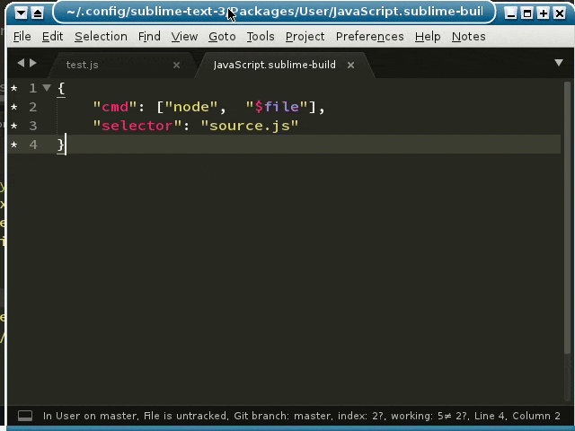
You can check out the official documentation on build systems for more information on the options available to you in a build system.
Important notes:
- If you get an error like command not found or something similar, it means that you either entered the command incorrectly, that program is not installed, or you need to tell your computer (and thus Sublime) where to find it by modifying your PATH; how you do that is system specific.
- Make sure you save a new file manually at least once before you try to run it; before you do the file isn't on disk yet and can't be executed, which can cause strange errors to occur. It can be a good idea to make sure that Tools > Save all on build is checked to ensure your files on disk are always up to date when you build, but this won't save a new file that doesn't have a name yet.
- I said this twice, but it bears repeating; if you need to interact with a command in any way, this won't work for you (without changes on your end). This includes if you try to execute a script that wants you to interact with it (e.g. it asks you your name and then prints it and such like). In such a case your program will seem to hang forever because it's waiting for input that you can't provide.

